**Project Title : Online Result Management System** ( Servlet & JSP , Oracle)

**Project Requirements :**

1. Eclipse IDE
2. Jdbc.jar & Log4j.jar file
3. JSP Form
4. Servlet
5. Filter
6. Resource Bundle
7. Lo4j
8. Database.

**Summary :**

In this Mini Project we are using Java Servlet and JSP pages to perform some Operations on Oracle XE 11 Database like Adding records, Displaying All records, etc.

**Introduction about the project :**

Technology Specifications used in project ( Java Language, Eclipse IDE,Database Language & Oracle XE 11 Database )

**JSP Used :**

1. Welcome.jsp:this jsp page is Home / default page

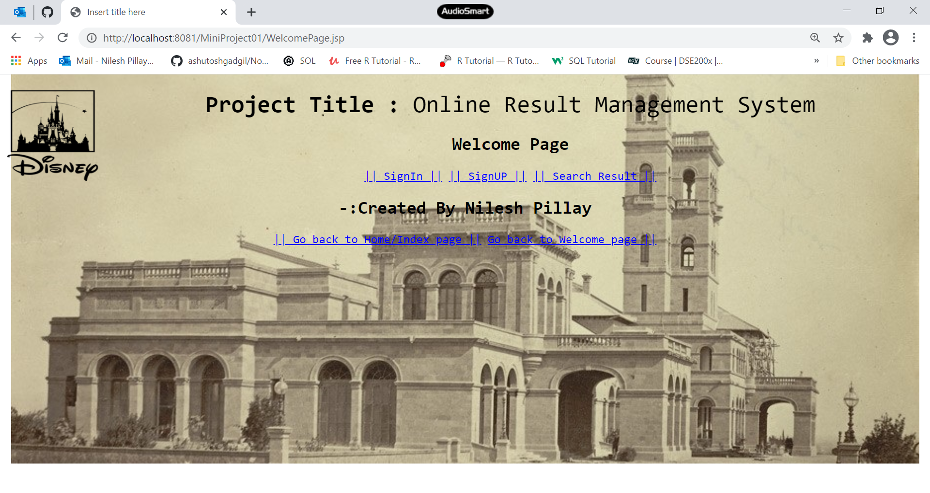

1. SignIn.jsp:this jsp page is form Admin SignIn .

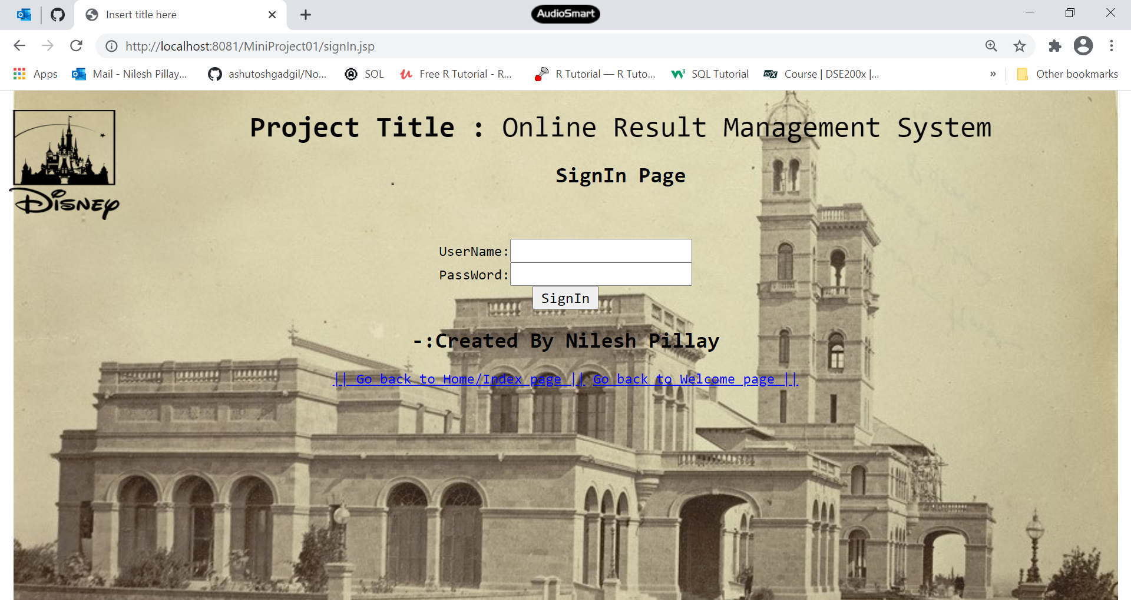

1. signUp.jsp:this page is for SignUp as Admin.

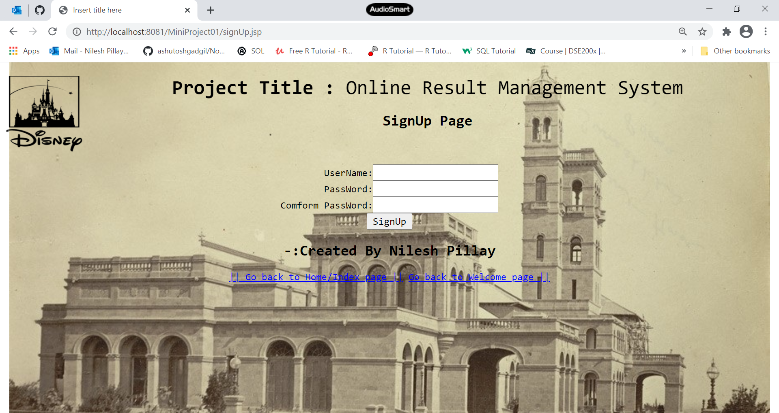

1. index.jsp: this jsp page is index page for this project which contains all hyper link of the project.

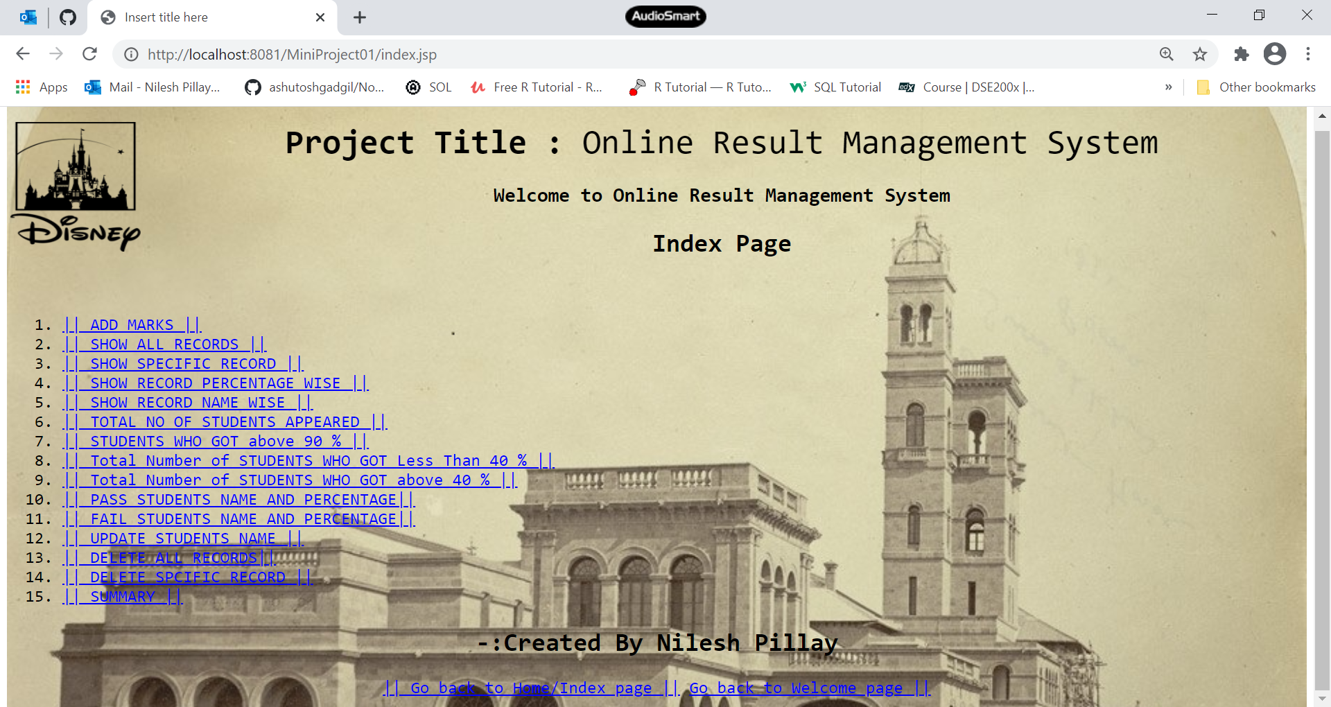

1. AddMarksForm:this page is a form for accepting data for database.

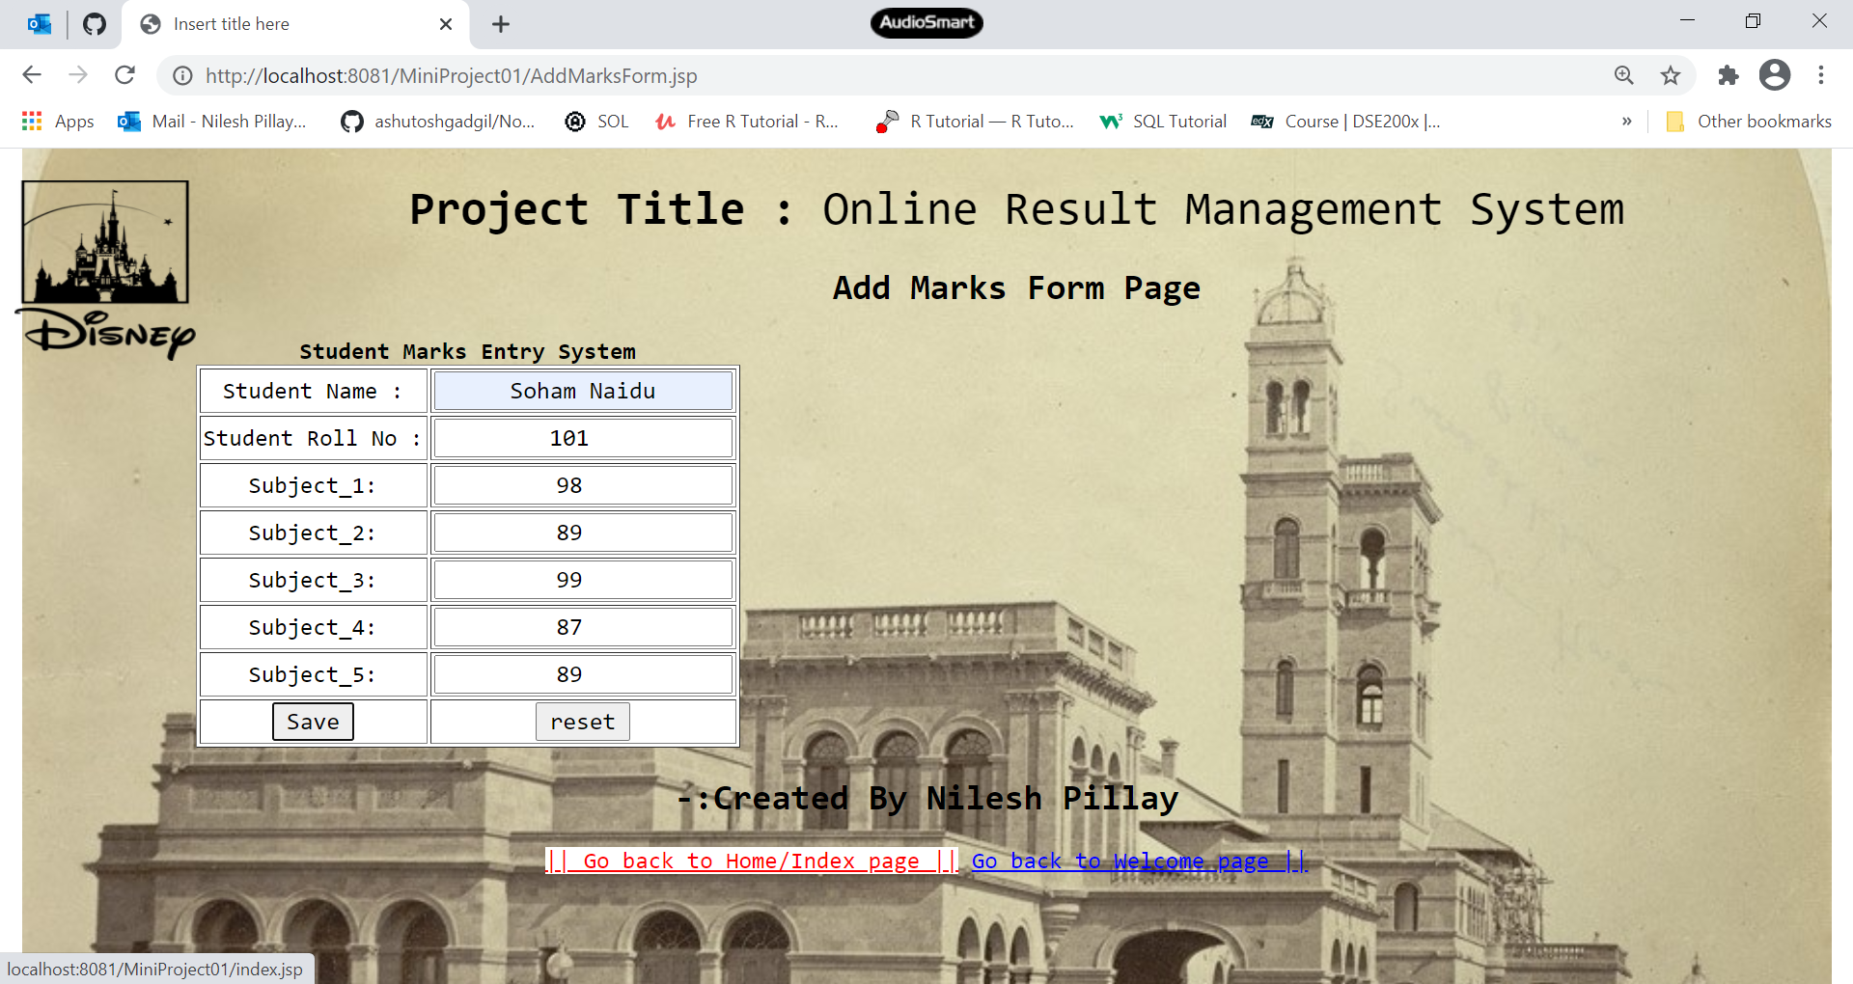

1. DisplaySpecfic.jsp: this page is a form for Displaying a specific record through Roll No.

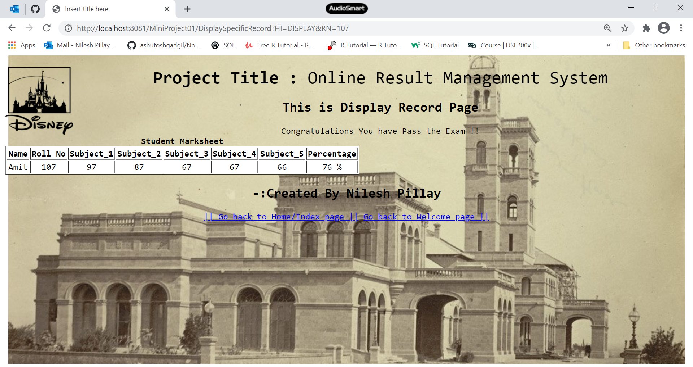

1. DeleteSpecificRecord.jsp:this page Delete a specific Record.

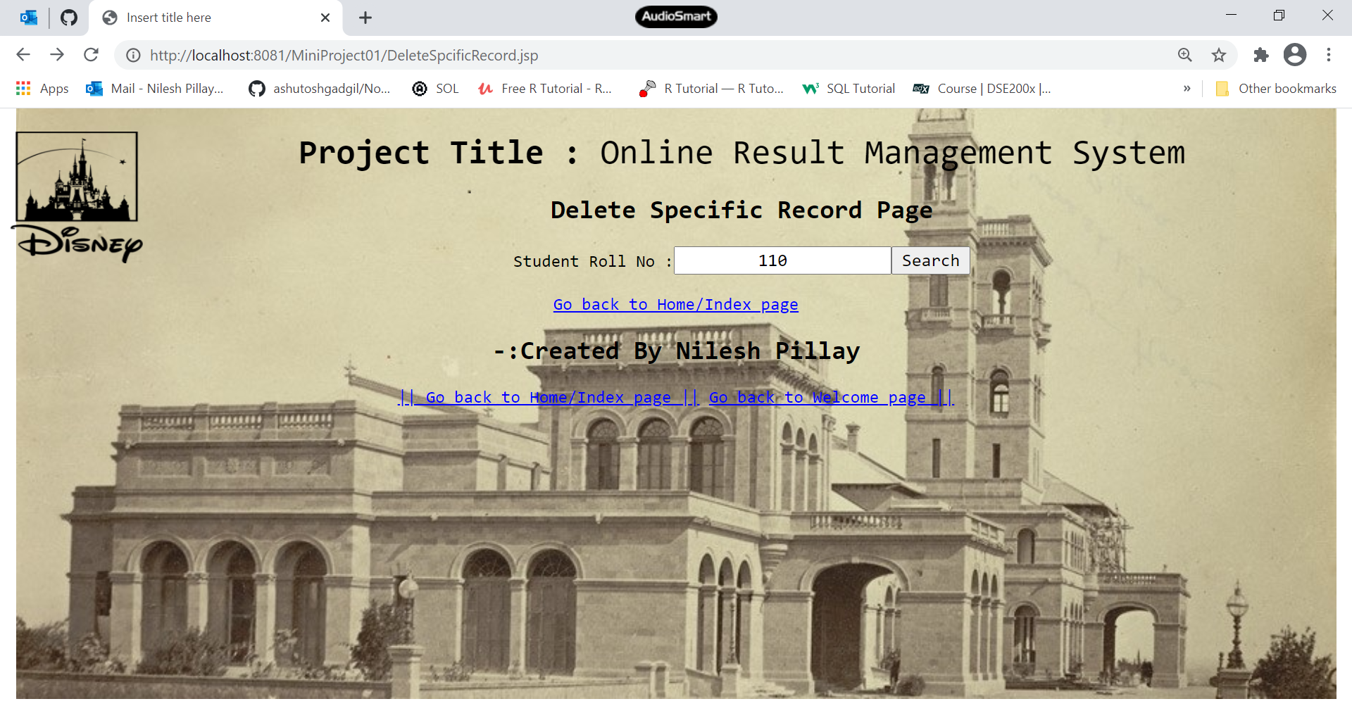

1. DisplayAllRecord.jsp:this page Display All record.

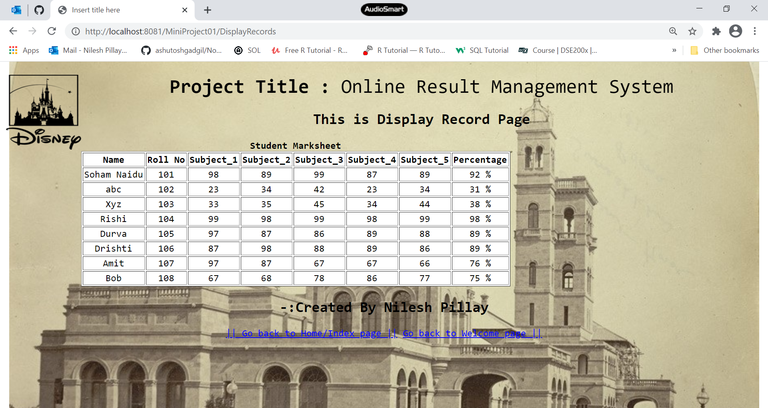

1. DisplayRecordPercentageWiseDesc.jsp:this page Display All record Percentage Wise .

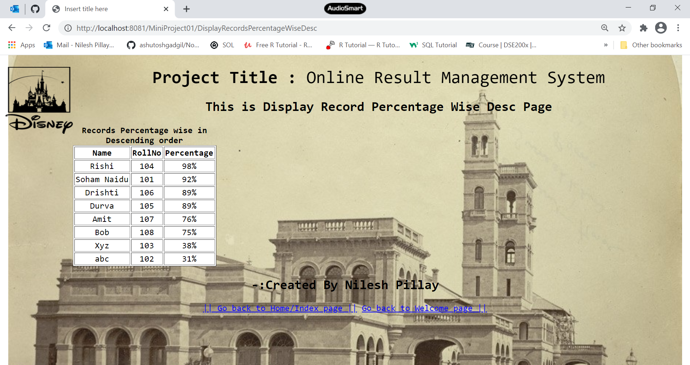

1. DisplayRecordOfStudentWhoArePass.jsp:this page Display only Pass Students

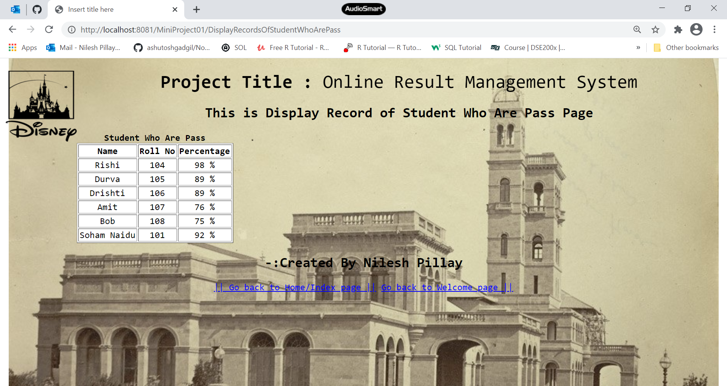

1. DisplayRecordOfStudentWhoAreFail.jsp :this page Display only Fail Students

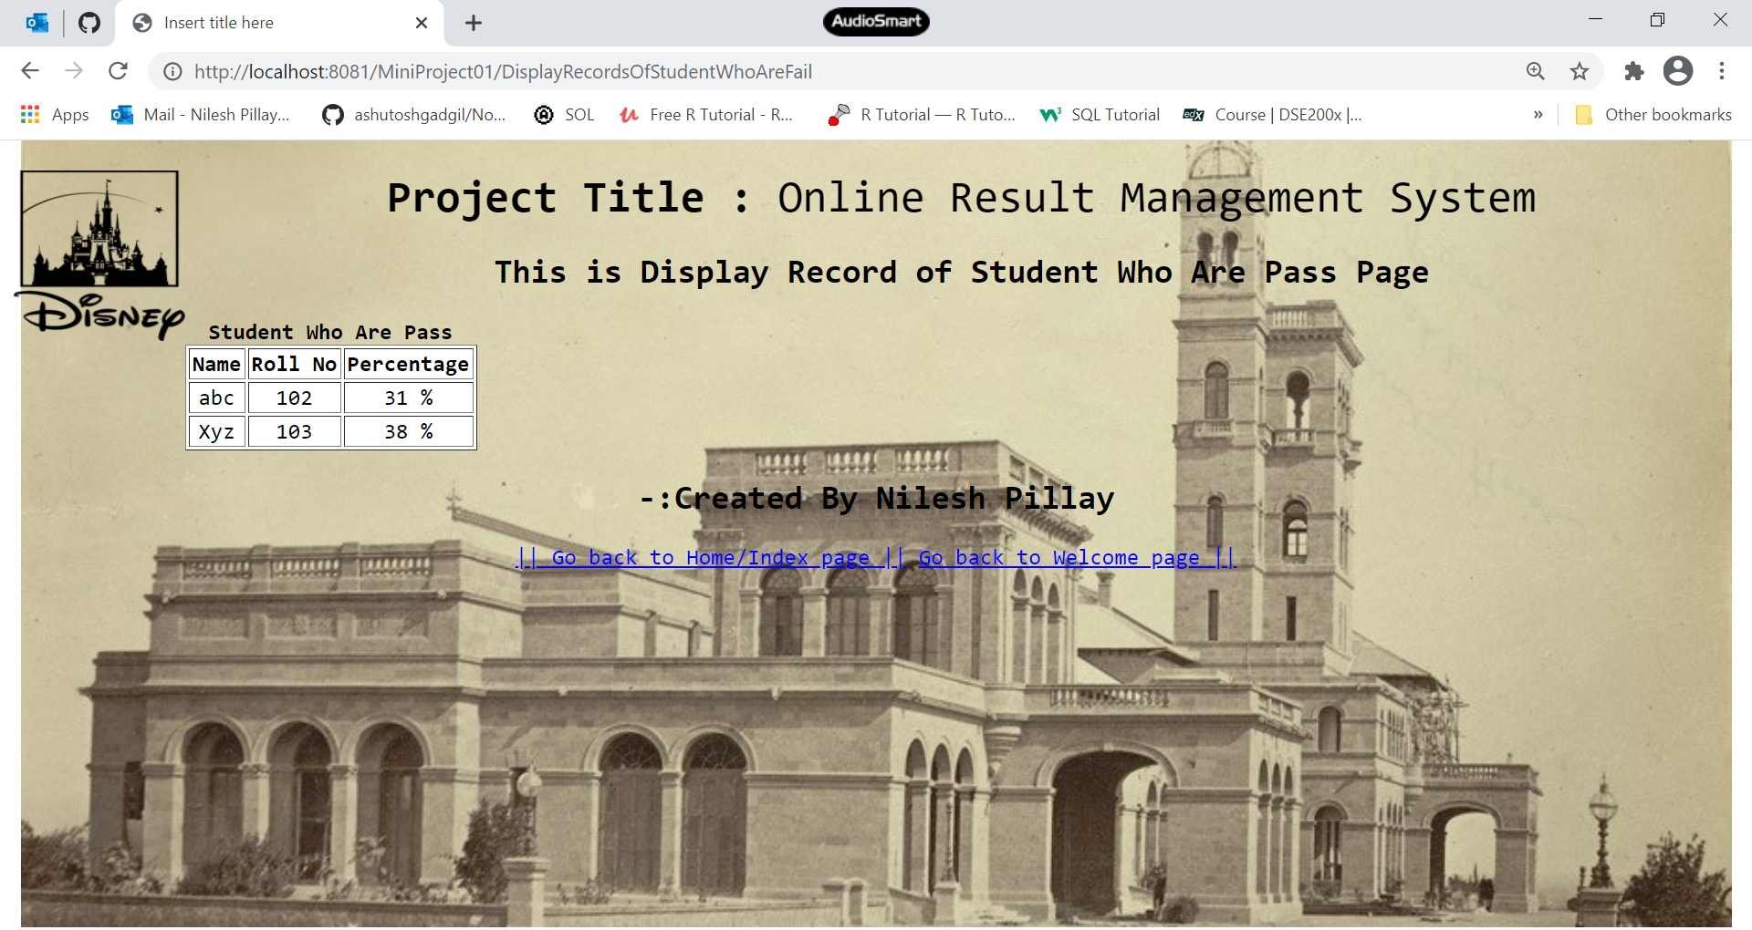

1. DisplayStatementTotal.jsp:this page Display Statement of total Student who appeared in exam

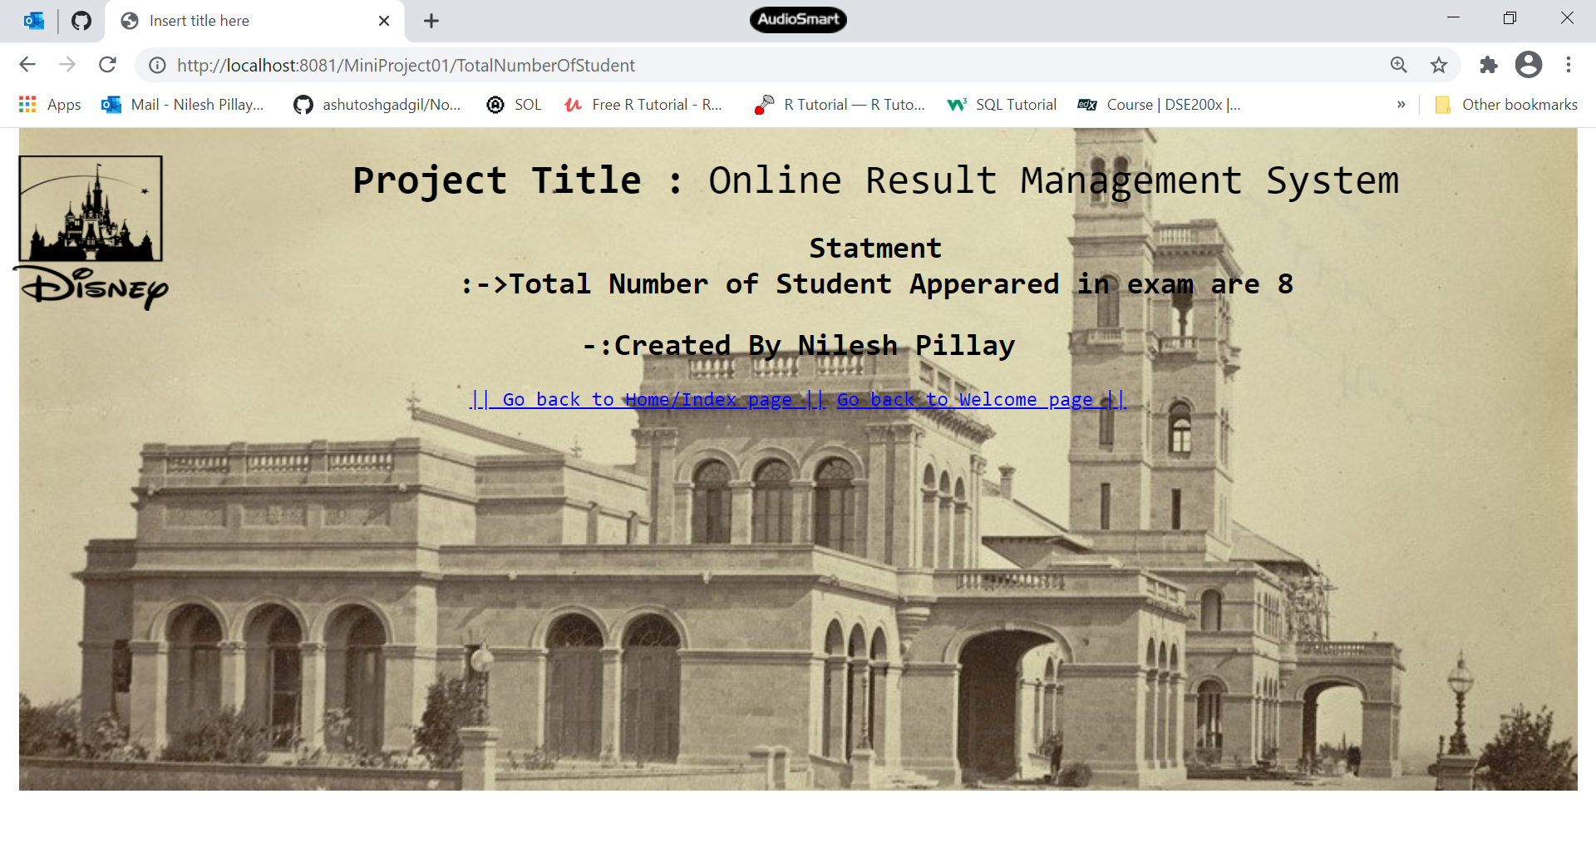

1. DisplayStatementTotalPass.jsp:this page Display Statement of Student Pass in exam.

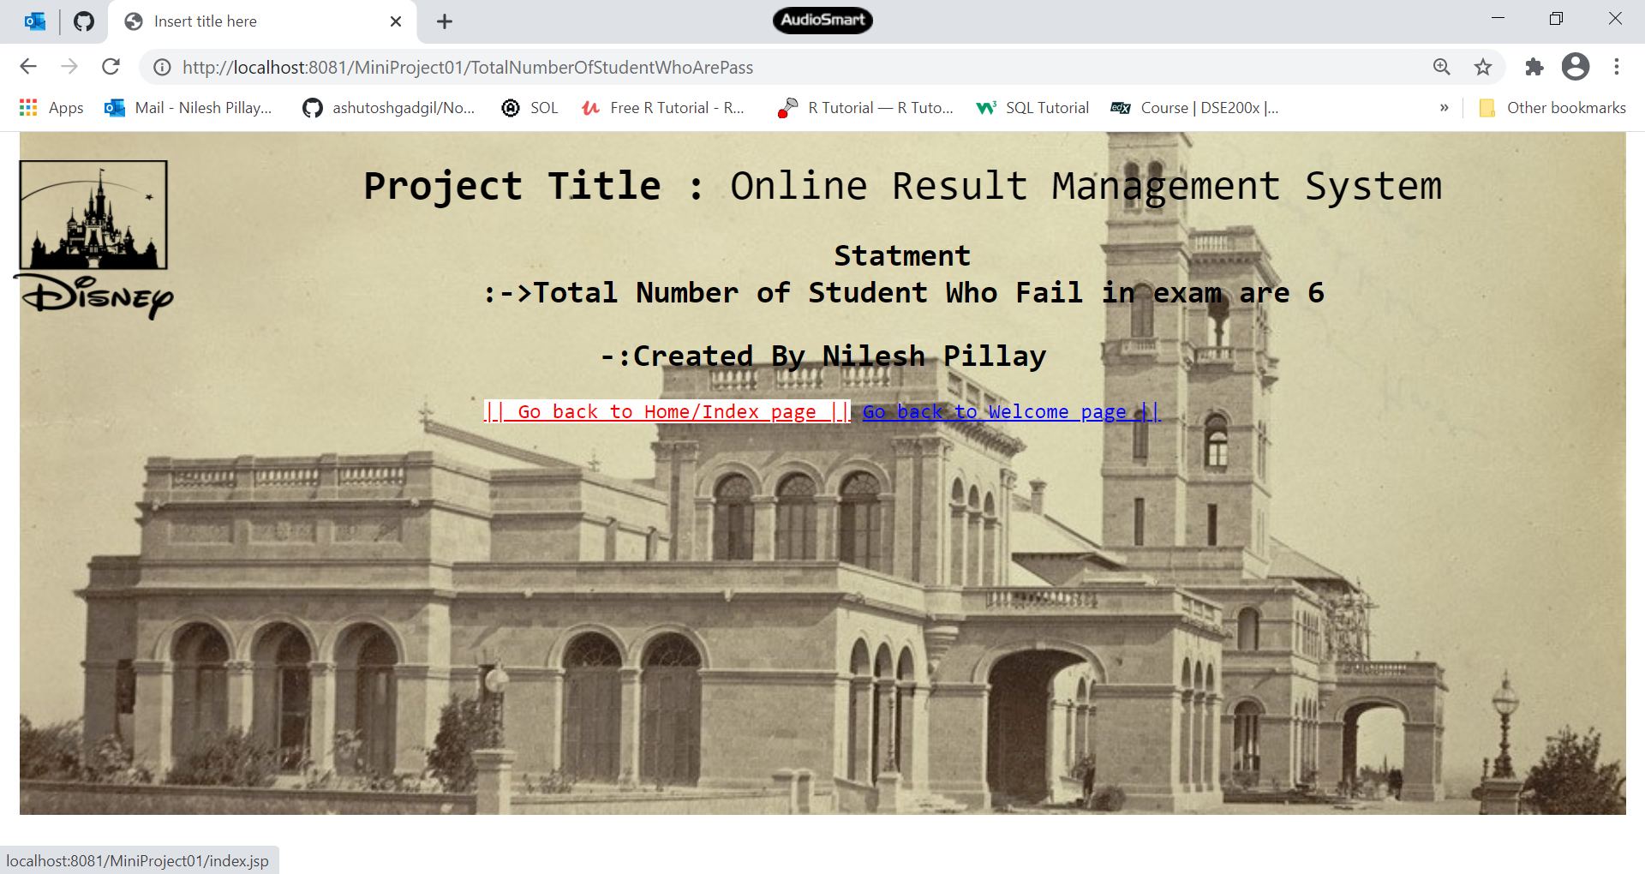

1. DisplayStatementTotalFail.jsp:this page Display Statement of Student Fail in exam.

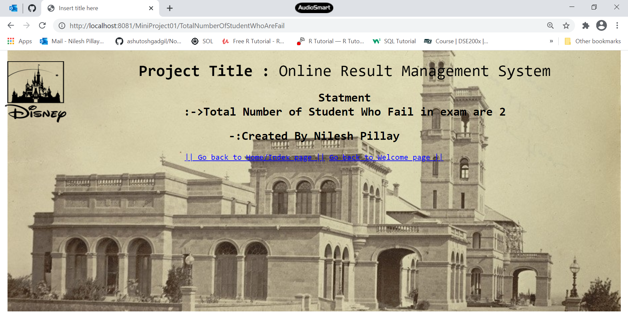

1. SpecificRecord.jsp:this page is Displaying a specific record through Roll No.

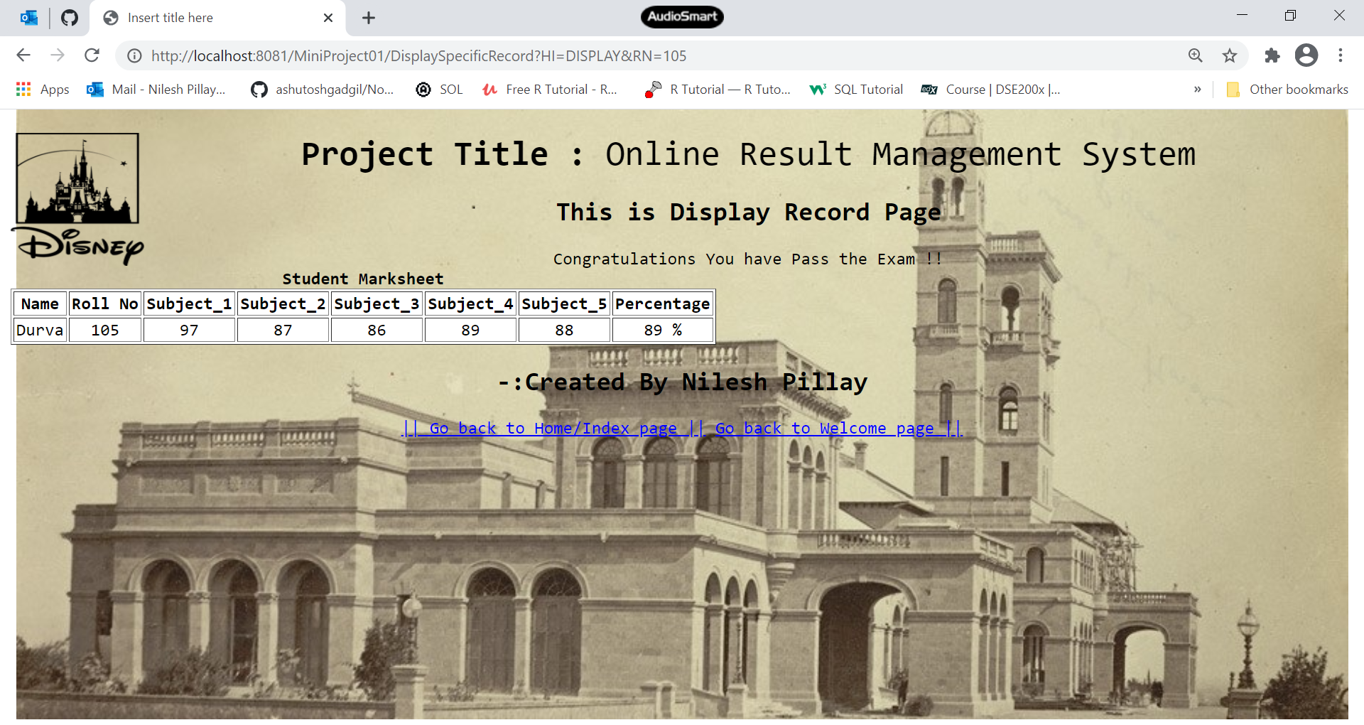

18.Summary.jsp:This page Display Table of Student appeared ,pass and fail in exam.

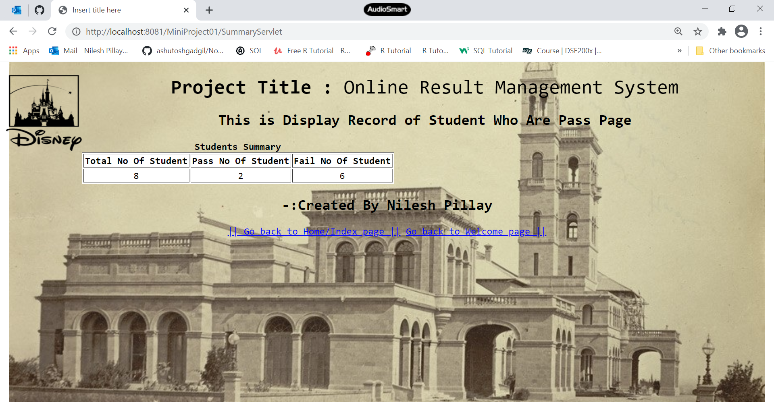

19.UpdateName.jsp:this page is for Deleting a specific record through Roll No.

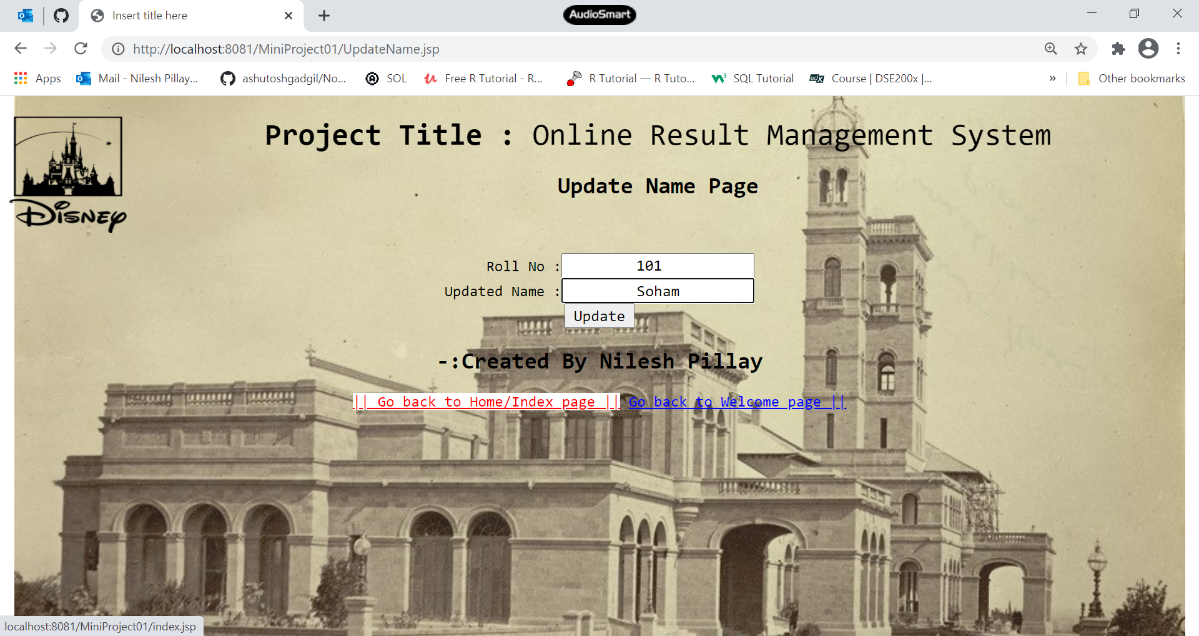

20.Footer.jsp

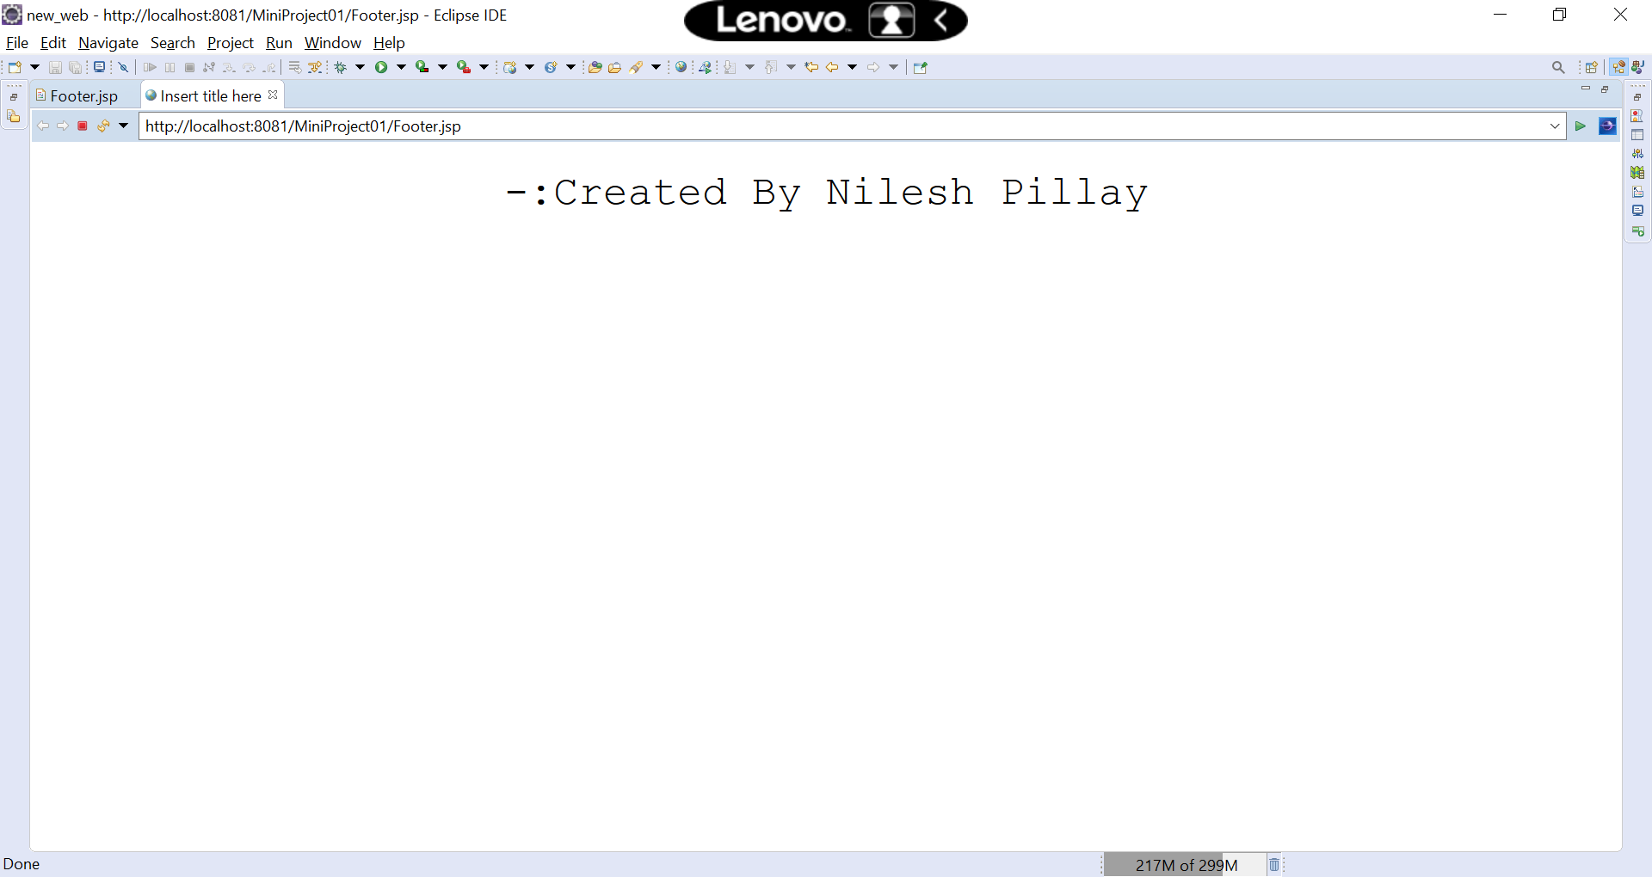

This report was made by Nilesh Pillay (UGT Trainee 2020)